**1. Requirement Gathering**

Online Pharmacy

**2. Analysis & SRS**

**Step: 1 Define module/user/actor**

Guest      - Website

Customer - Website

Admin          - Admin panel

**Step: 2 Define each module Task**

**Guest:**

View category

View Product

View Doctor

View Blog

Contact us

**Customer:**

Registration

Login

View Category

View Products

View Doctor

View Blog

Special Offers

Lab Tests

Contact Us

Manage Profile

Add to Cart

Manage Cart

Place Order

Manage Order

Logout

**Admin:**

Login

Manage category

Mange Product

Manage Doctor

Manage Blog

Manage Special Offers

Manage Lab Tests

Manage Orders

View Customers

View Cart Report

View Order Report

View Lab Report

View Special Offers

**Step: 3 Define all Diagrams**

**1. Use Case Diagram:**

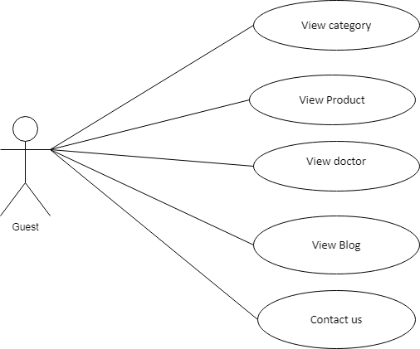

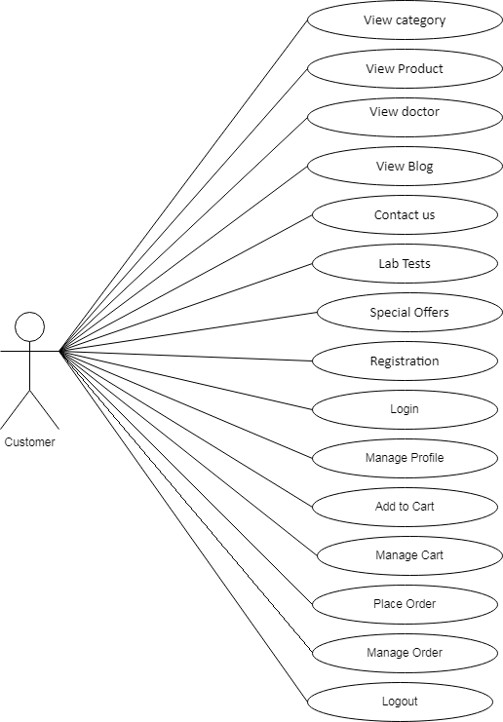

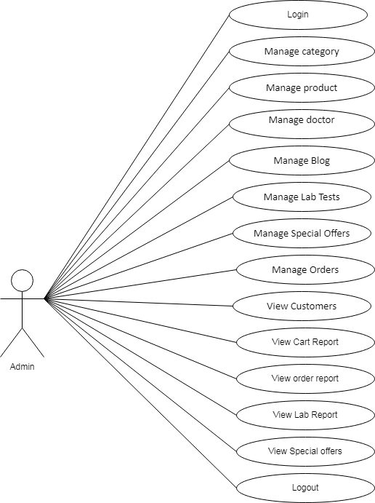

**2. DFD Data Flow Diagram**

**Level 0 / Context Level**

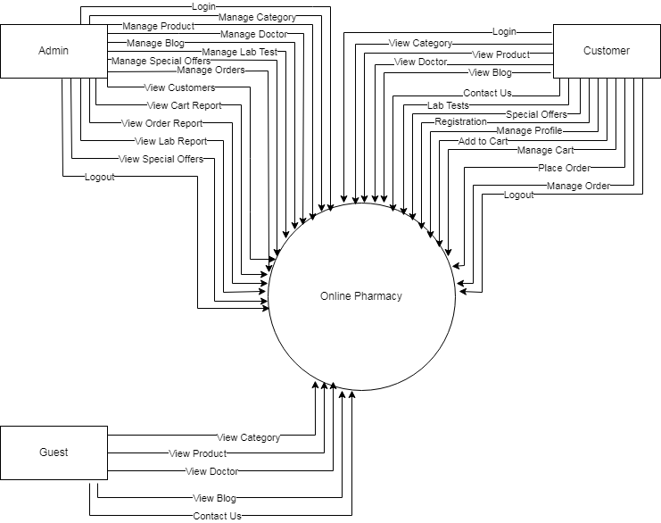

**Level 1: Admin DFD**

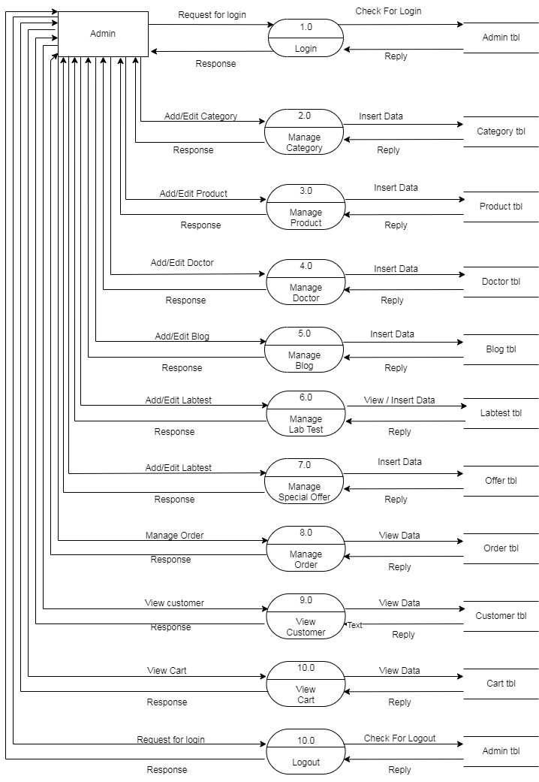

**Level 1: Customer DFD**

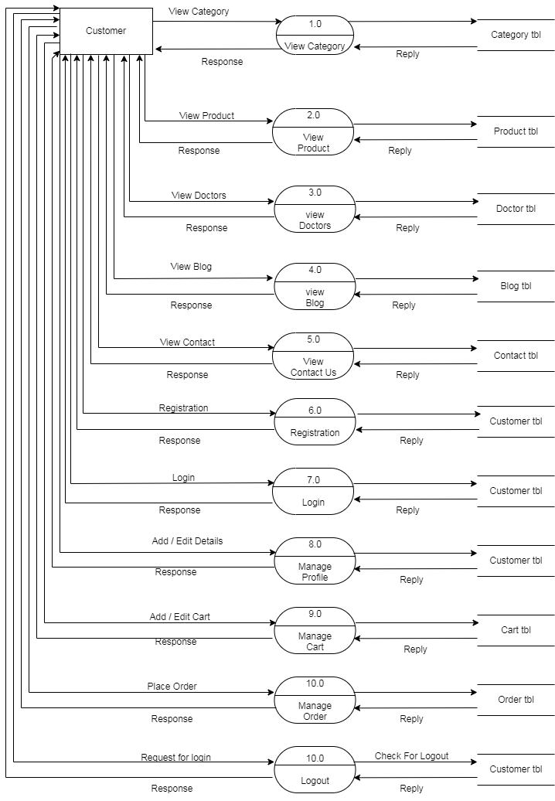

**Level 1: Guest DFD**

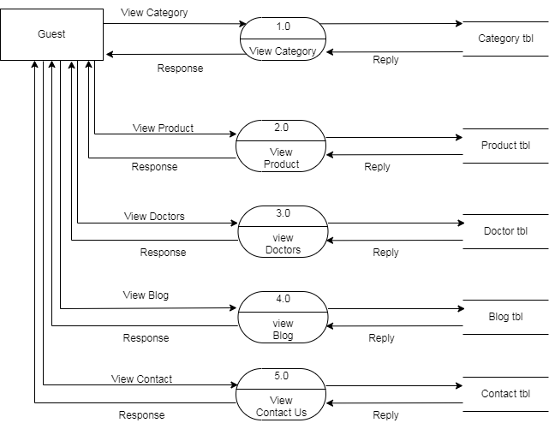

**Step: 4 Find Total Number of Table**

Category Tbl

Product Tbl

Doctor Tbl

Blog Tbl

Customer Tbl

Contact Tbl

Cart Tbl

Order Tbl

Labtest Tbl

Offer Tbl

Admin Tbl

**Step: 5 Define each Table Column**

**Category tbl:**

Category_id **PK**

Category_name

Category_img

Created _date

Updated_date

**Product tbl:**

Product_id **PK**

Category_id **FK**

Product_name

Product_mainprice

Product_img

Product_desc

Created _date

Updated_date

**Doctor tbl:**

Doctor_id **PK**

Name

Speciality

Email

Mobile

Address

Created _date

Updated_date

**Contact tbl:**

Contact_id **PK**

Name

Email

Comment

Created _date

Updated_date

**Customer tbl:**

Customer_id **PK**

Name

Username

Password

E-mail

Mobile

Address

Created _date

Updated_date

**Cart tbl:**

Cart_id **PK**

Product_id **FK**

qty

Created _date

Updated_date

**Order tbl:**

Order_id **PK**

Customer_id **FK**

Cart_id **FK**

Total Amount

Created _date

Updated_date

**Labtest tbl:**

Test_id **PK**

Doctor_id **FK**

Customer_id **FK**

Test_title

Test_desc

Test_price

Created _date

Updated_date

**Offer tbl:**

Offer_id **PK**

Product_id **FK**

Product_discprice

Created _date

Updated_date

**Blog tbl:**

Blog_id **PK**

Title

Image

Description

Created _date

Updated_date

**Admin tbl:**

Admin_id **PK**

Username

Password

Created _date

Updated_date

**As above column create data dictionary**

**Category tbl:**

| **Field Name** | **Data Type** | **Field Length** | **Constraint** | **Description** |
| --- | --- | --- | --- | --- |
| Cat_id | int | 11 | primary key | category id , auto generated |
| Cat_name | varchar | 256 | not null | name of category table |
| Cat_img | varchar | 256 | not null | image of category table |
| Created_dt | date |  | not null | create date of category table |
| Updated_dt | date |  | not null | updated date of category table |

**Product tbl:**

| **Field Name** | **Data Type** | **Field Length** | **Constraint** | **Description** |
| --- | --- | --- | --- | --- |
| Product_id | int | 11 | primary key | product id , auto generated |
| Cat_id | int | 11 | Foreign Key | category id , foreign key use |
| Prod_name | varchar | 256 | not null | name of product |
| Prod_mainprice | int | 11 | not null | main price of product |
| Prod_discprice | int | 11 | not null | discount of product price |
| Prod_img | varchar | 256 | not null | image of product |
| Prod_desc | varchar | 256 | not null | Description of product |
| Created_dt | date |  | not null | created date of product table |
| Updated_dt | date |  | not null | updated date of product table |

**Doctor tbl:**

| **Field Name** | **Data Type** | **Field Length** | **Constraint** | **Description** |
| --- | --- | --- | --- | --- |
| Doctor_id | int | 11 | primary key | Doctor id , auto generated |
| Doc_name | varchar | 256 | not null | name of doctor |
| doc_email | varchar | 256 | not null | Email of doctor |
| doc_mobile | varchar | 256 | not null | Mobile number of doctor |
| doc_address | varchar | 256 | not null | Address of doctor |
| Created_dt | date |  | not null | created date of doctor table |
| Updated_dt | date |  | not null | updated date of doctor table |

**Contact tbl**

| **Field Name** | **Data Type** | **Field Length** | **Constraint** | **Description** |
| --- | --- | --- | --- | --- |
| Contact_id | int | 11 | primary key | contact id , auto generated |
| Name | varchar | 256 | not null | name of contact name |
| Email | varchar | 256 | not null | email of contact table |
| Comment | varchar | 256 | not null | comment of contact table |
| Created_dt | date |  | not null | created date of contact table |
| Updated_dt | date |  | not null | updated date of contact table |

**Customer tbl**

| **Field Name** | **Data Type** | **Field Length** | **Constraint** | **Description** |
| --- | --- | --- | --- | --- |
| Cust_id | int | 11 | primary key | customer id , auto generated |
| Name | varchar | 256 | not null | name of customer |
| Username | varchar | 256 | not null | user name of customer |
| Password | varchar | 256 | not null | password of customer |
| Email | varchar | 256 | not null | email of customer |
| mobile | varchar | 256 | not null | mobile of customer |
| Address | varchar | 256 | not null | Address of customer |
| Created_dt | date |  | not null | created date of customer table |
| Updated_dt | date |  | not null | updated date of customer table |

**Cart tbl**

| **Field Name** | **Data Type** | **Field Length** | **Constraint** | **Description** |
| --- | --- | --- | --- | --- |
| Cart_id | int | 11 | primary key | cart id , auto generated |
| Product_id | int | 11 | foreign key | product id , foreign key use |
| qty | int | 11 | not null | qty of cart table |
| Created_dt | date |  | not null | created date of cart table |
| Updated_dt | date |  | not null | updated date of cart table |

**Order tbl**

| **Field Name** | **Data Type** | **Field Length** | **Constraint** | **Description** |
| --- | --- | --- | --- | --- |
| Order_id | int | 11 | primary key | order id , auto generated |
| Cust_id | int | 11 | foreign key | cust id , foreign key use |
| Cart_id | int | 11 | foreign key | cart id , foreign key use |
| Total Amount | int | 11 | not null | total amount of order table |
| Created_dt | date |  | not null | created date of order table |
| Updated_dt | date |  | not null | updated date of order table |

**Labtest tbl**

| **Field Name** | **Data Type** | **Field Length** | **Constraint** | **Description** |
| --- | --- | --- | --- | --- |
| test_id | int | 11 | primary key | test id , auto generated |
| doc_id | int | 11 | foreign key | doc id , foreign key use |
| Cust_id | int | 11 | foreign key | cust id , foreign key use |
| Test_desc | varchar | 256 | not null | Description of test |
| test_price | int | 11 | not null | total amount of test table |
| Created_dt | date |  | not null | created date of order table |
| Updated_dt | date |  | not null | updated date of order table |

**Offer tbl**

| **Field Name** | **Data Type** | **Field Length** | **Constraint** | **Description** |
| --- | --- | --- | --- | --- |
| Offer_id | int | 11 | primary key | offer id , auto generated |
| Product_id | int | 11 | foreign key | Product id , foreign key use |
| Prod_discprice | int | 11 | not null | discount of product price |
| Created_dt | date |  | not null | created date of order table |
| Updated_dt | date |  | not null | updated date of order table |

**Blog tbl**

| **Field Name** | **Data Type** | **Field Length** | **Constraint** | **Description** |
| --- | --- | --- | --- | --- |
| Blog_id | int | 11 | primary key | blog id , auto generated |
| Title | varchar | 256 | not null | title of blog table |
| Img | varchar | 256 | not null | image of blog table |
| description | varchar | 256 | not null | description of blog table |
| Created_dt | date |  | not null | created date of blog table |
| Updated_dt | date |  | not null | updated date of blog table |

**Admin tbl**

| **Field Name** | **Data Type** | **Field Length** | **Constraint** | **Description** |
| --- | --- | --- | --- | --- |
| Admin_id | int | 11 | primary key | admin id , auto generated |
| Username | varchar | 256 | not null | user name of admin table |
| password | varchar | 256 | not null | password of admin table |
| Created_dt | date |  | not null | created date of blog table |
| Updated_dt | date |  | not null | updated date of blog table |